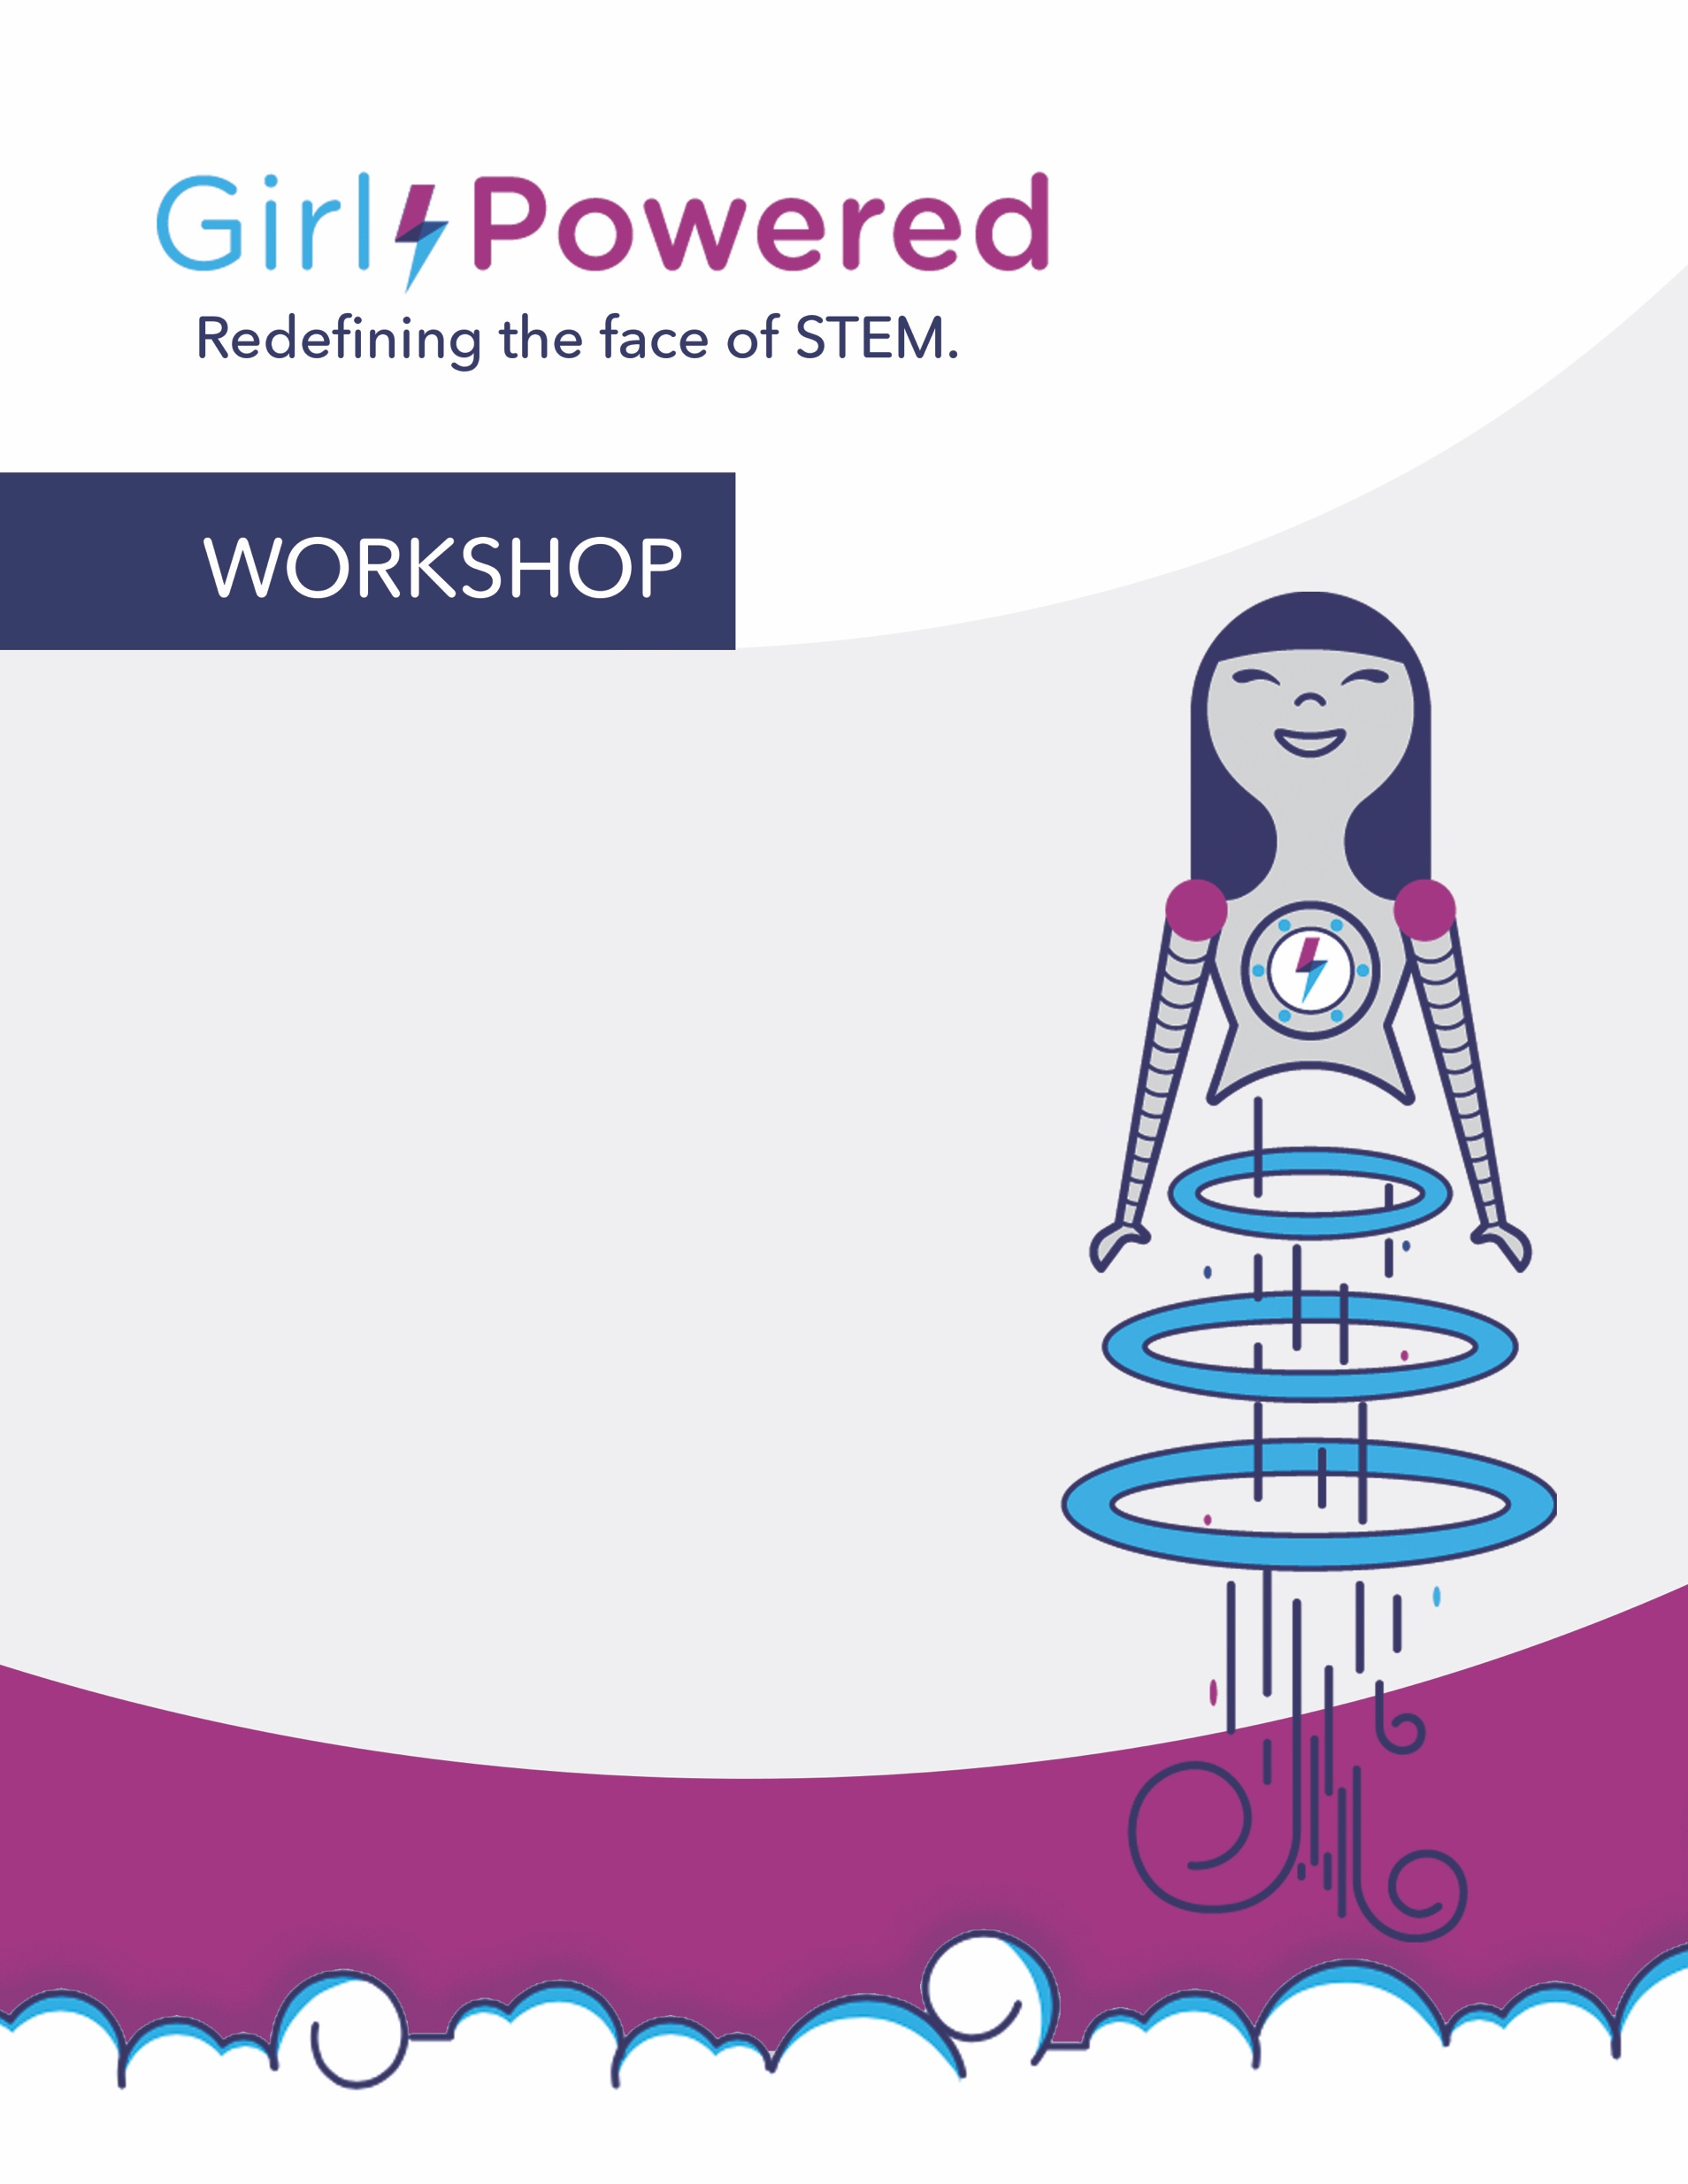

**Date:**

**Time:**

**Location:**

In celebration of International Day of Girl, students with an interest in STEM are invited to join us for a fun-filled evening of hands-on activities!

The event will kick-off with an interactive Q&A from technology thought leaders, then flow into a series of activities scaled for students ranging from grades 4-12. and will include refreshments, giveaways and prizes.

**For more information about the initiative visit GirlPowered.com**